**TECHNICAL REPORT ON STUDENT INDUSTRIAL WORK EXPERIENCE SCHEME (SIWES)**

**AT**

**PANGEA COMPUTER TECHNOLOGY TRAINING INSTITUTE,**

**BIU, BORNO STATE**

**FROM: 4TH MAY, 2023**

**TO: 4TH JUNE, 2023**

**BY**

**Markus samuel**

**ST/CS/ND/21/037**

**SUBMITTED TO THE DEPARTMENT OF COMPUTER SCIENCE, SCHOOL OF SCIENCE AND TECHNOLOGY, IN PARTIAL FULFILLMENT OF THE REQUIREMENT FOR THE AWARD OF NATIONAL DIPLOMA (ND), COMPUTER SCIENCE, FEDERAL POLYTECHNIC, MUBI, ADAMAWA STATE.**

**JUNE, 2023**

**DEDICATION**

I wish to dedicate this piece of work to Almighty God who kept me alive and for his guidance throughout my industrial training program.

I also dedicate it to my parent and my brother in parsons of Samuel Ali Malgwi and to my lovely mom Mary Samuel and my brother Irimya who gave me their full support financially and also encouraged me and supported me during my industrial training fund (ITF) program.

**ACKNOWLEDGEMENT**

I wish to express my praise to Almighty GOD the creator of the universe for His protection and guidance. I am indebted and sincerely acknowledged the effort of my beloved parents Mr. Ali Malgwi and Mrs. Mary Samuel Ali Malgwi for their moral and financial support throughout my industrial training. I believed that this exercise would not have been a success without their encouragement. I also wish to acknowledge the contributions and guidance of my able, kind patient and hardworking industrial based supervisor Mr. Ezra Peter I pray that the Almighty GOD bless you abundantly Amen.

Finally, I acknowledged the relentless efforts of my SIWES Coordinator and supervisor for their patience, support, advice and encouragement during the supervisors I pray that God will bless and reward them all.

**TABLE OF CONTENTS**

**Chapter One**

1.1 Historical background of SIWES - - - - - - - 1

1.2 Aims and objectives- - - - - - - - - 2

1.3 History of the SIWES location- - - - - - - - 3

**Chapter Two**

2.1 Microsoft Excel- - - - - - - - - - 4

2.2 Introduction to Excel- - - - - - - - - 5

2.3 Simple Calculation in Excel - - - - - - - - 6

2.4 Git bash- - - - - - - - - - - 7

2.5 Command in Git bash- - - - - - - - - 8

**Chapter Three**

3.1 Python Programming- - - - - - - - - 10

**Chapter Four**

4.1 Challenges- - - - - - - - - - 12

4.2 Summary- - - - - - - - - - - 12

4.3 Conclusion- - - - - - - - - - 12

4.4 Recommendations - - - - - - - - - 12

**CHAPTER ONE**

**1.0 INTRODUCTION**

The concept behind industrial training schemes is to acquire practical, knowledge in addition to what has been learn institution. The four months mandatory supervised industrial attachment is program instituted by the federal government to help student for their different field of studies.

### **1.1 BACKGROUND OF SIWES**

It aims at exposing student to the practical and the actualization of work situation which they may meet after graduation and the learning is meanly expected to produce graduate qualification to meet man power of employments of (ITF), there was growing concern amount the industrialist that graduate of higher learning do not passes adequate background student for the opinion that theoretical education going higher institution was responsive enough to meet the need of employers of the labour as a requirement of national board for technical education (NBTE) polytechnic training before obtaining the National Diploma (ND).

Experience scheme (SIWES), is a National programme introduced by Government in 1974 for student in tertiary institution

### **1.2 BRIEF HISTORY OF SIWES**

**SIWES** was established by **ITF** in 1973 to solve the problem of lack of adequate practical skills preparatory for employment in industries by Nigerian graduates of tertiary institutions.

The program “Student industrial work experience scheme” is a pure skill-acquisition program structured for the tertiary institutions as a complementary and enhancement program to the theoretical education, laboratory and workshop practices engaged in by student in different higher institutions. The SIWES was initiated to improve the student’s technical abilities (performance/knowledge) and expose them to industrial culture thereby preparing them to be acquainted with the roles to play towards the technological advancement of the nation.

It is there for a practical aspect of the academic works, which the students may not be opportune to carry out throughout their stay in the higher institutions. Based on this fact, the Federal Government decided to establish a body (regulatory) which engages in the training of the technical manpower. The body is named industrial Training Fund (ITF). The government also undertook to make up for the deficiencies by structuring and established Students Industrial Training (SIT) as it was then called but in 1973 the SIWES was formed which is the subsidiary.

### **1.3 AIMS AND OBJECTIVES OF SIWES**

1. One of the objectives of SIWES is to create an avenue for students to acquire industrial skills to complement their theoretical knowledge and improve their experiences in their course of study.
2. The program prepares the students for industrial working conditions prior to their graduation.
3. To enable the students to learn personal relationship with employers and co-employees on graduation.
4. It exposes the student to working methods and techniques in handling equipment and machinery.
5. It develops the student in make critical and realistic approaches to solving problem.
6. It serves as a way of improving the abilities of the students and to contribute to the growth of the nation.
7. It gives the students the opportunity to practice what they have been taught in various disciplines.
8. The SIWES program strengthens the employer’s involvement in preparing the students for employment.

**CHAPTER TWO**

**2.1 BRIEF HISTORICAL BACKGROUND OF PANGEA COMPUTER TECHNOLOGY TRAINING INSTITUTE BIU**

Pangea Computer Technology Training Institute is a school that trains students on computer fundamental studies with the view of self-sustenance. It help student to acquire skilful method of computing. It is situated at No: 2 Nassarawa opposite Binta Sudan Filling Station along Gombe Road, Biu, Borno State. Pangea Computer Technology Training Institute was established in 2004 by Rev. Ari Mai Sule Biu through the assistance of Rotary club International San Diego club (U.S.A). The school has since been An Affiliate of Kwari Computer Academy Maiduguri.

Pangea Computer Technology Training Institute offer practical knowledge of computing ranging from Hardware Maintenance, Networking, Web Technology including HTML,CSS,PHP, and General Computer Application including Microsoft Office Suit which comprises of Microsoft Office Word, Microsoft Excel, Microsoft Power Point, Microsoft Access Data base and a lot more, it also offer Diploma and Certificate in the courses mentioned above.

**2.2 ORGANIZATIONAL CHART**

Figure 2.1: Organizational Chart

**Chapter three**

**EXPERIECE ACQUIRED DURING TRAINING**

**3.1 MICROSOFT EXCEL**

Microsoft Excel is the most widely used spreadsheet, and is available within the Microsoft Office suite of programs. As you work through this introduction to Excel, it is a good idea to be at a computer so that you can try out various things as they are described. To get into Excel, simply double click on the Microsoft Excel icon if there is one on the computer desktop. Alternatively, click on the Start button in the bottom left corner of the screen, move the cursor to Programs to open up the programs menu, and then click on Microsoft Excel. Your computer should display the basic Excel screen.

**3.2 INTRODUCTION TO EXCEL**

Anyone who has used a computer for more than just playing games will be aware of spreadsheets. A spreadsheet is a versatile computer program (package) that enables you to do a wide range of calculations *dynamically*, and create high quality graphs and charts. Microsoft Excel is the most widely used spreadsheet, and is available within the Microsoft Office suite of programs.

As you work through this introduction to Excel, it is a good idea to be at a computer so that you can try out various things as they are described. To get into Excel, simply double click on the Microsoft Excel icon if there is one on the computer desktop. Alternatively, click on the Start button in the bottom left corner of the screen, move the cursor to Programs to open up the programs menu, and then click on Microsoft Excel. Your computer should display the basic Excel screen shown in Figure 1. You are now ready to use Excel.

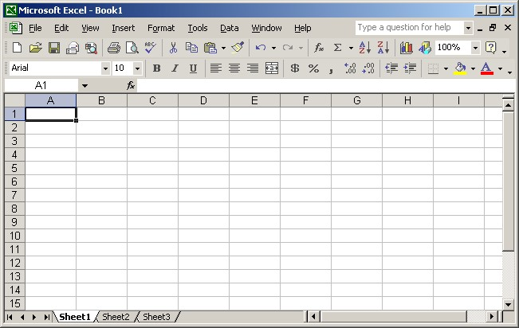

Figure 1: Basic Excel Screen

The bulk of the screen is devoted to displaying a spreadsheet, which is one of many similar sheets that make up an Excel workbook. By default, the workbook is set up with 3 sheets, but this can be extended by creating additional sheets as required. In simple examples, you will often be able to organize your work on a single sheet, but for more complicated problems it may be more convenient to use several sheets. Different sheets are accessed by clicking on the appropriate *Tab* at the bottom of the screen. It is also possible to give the sheets more meaningful names, rather than the default names Sheet1, Sheet2, Sheet3 etc. Simply right click on the Tab to open up a menu allowing you to (among other things) *Insert*, *Delete* or *Rename* the worksheet.

**3.1.3 SIMPLE CALCULATION**

For simple formulas, simply type the equal sign followed by the numeric values that you want to calculate and the math operators that you want to use — the plus sign (+) to add, the minus sign (-) to subtract, the asterisk (*) to multiply, and the forward slash (/) to divide.

**3.2 Git Bash**

At its core, Git is a set of command line utility programs that are designed to execute on a Unix style command-line environment. Modern operating systems like Linux and macOS both include built-in Unix command line terminals. This makes Linux and macOS complementary operating systems when working with Git. Microsoft Windows instead uses Windows command prompt, a non-Unix terminal environment.

In Windows environments, Git is often packaged as part of higher level GUI applications. GUIs for Git may attempt to abstract and hide the underlying version control system primitives. This can be a great aid for Git beginners to rapidly contribute to a project. Once a project’s collaboration requirements grow with other team members, it is critical to be aware of how the actual raw Git methods work. This is when it can be beneficial to drop a GUI version for the command line tools. Git Bash is offered to provide a terminal Git experience.

**3.2.1 What is Git Bash?**

Git Bash is an application for Microsoft Windows environments which provides an emulation layer for a Git command line experience. Bash is an acronym for Bourne Again Shell. A shell is a terminal application used to interface with an operating system through written commands. Bash is a popular default shell on Linux and macOS. Git Bash is a package that installs Bash, some common bash utilities, and Git on a Windows operating system.

**How to install Git Bash**

Git Bash comes included as part of the Git for Windows package. Download and install Git for Windows like other Windows applications. Once downloaded find the included .exe file and open to execute Git Bash.

**How to use Git Bash**

Git Bash has the same operations as a standard Bash experience. It will be helpful to review basic Bash usage. Advanced usage of Bash is outside the scope of this Git focused document.

**How to navigate folders**

The Bash command pwd is used to print the ‘present working directory’. Pwd is equivalent to executingcd on a DOS (Windows console host) terminal. This is the folder or path that the current Bash session resides in.

The Bash command ls is used to ‘list’ contents of the current working directory. Ls is equivalent to DIR on a Windows console host terminal.

Both Bash and Windows console host have acd command. Cd is an acronym for ‘Change Directory’. Cd is invoked with an appended directory name. Executing cd will change the terminal session’s current working directory to the passed directory argument.

**3.2.5 Git Bash Commands**

Here is a list of commonly used Git commands along with brief explanations:

1. **`git init`:** Initializes a new Git repository in the current directory, creating a new `.git` folder to store Git-related data.

2. **`git clone <repository_url>`:** Copies an existing Git repository from a remote server to your local machine, creating a local copy of the entire repository.

3. **`git add <file>`:** Adds a file or changes to the staging area, preparing them to be committed.

4. **`git commit -m "commit message"`:** Records the changes in the staging area to the repository, creating a new commit with a descriptive commit message.

5. `**git status`**: Shows the current status of the repository, including modified files, untracked files, and files in the staging area.

6. **`git diff`:** Displays the differences between the working directory and the staging area.

7. **`git log`:** Shows the commit history of the repository, displaying the commit hash, author, date, and commit message.

8. **`git branch`:** Lists all existing branches in the repository.

9. **`git checkout <branch_name>`:** Switches to the specified branch or commit.

10. **`git merge <branch_name>`:** Merges changes from the specified branch into the current branch.

11. **`git remote add <name> <repository_url>`:** Connects the local repository to a remote repository with the given name and URL.

12. **`git push <remote_name> <branch_name>`:** Sends committed changes to a remote repository, updating the branch specified.

13. **`git pull <remote_name> <branch_name>`:** Fetches and merges changes from a remote repository into the current branch.

14. **`git fetch`:** Fetches changes from a remote repository without automatically merging them.

15. **`git reset <commit>`:** Unstages the changes from the staging area, resetting the repository to the specified commit.

16. **`git rm <file>`:** Removes a file from the repository and the working directory.

17. **`git tag <tag_name>`:** Adds a tag to the current commit for easy reference.

**3.3 PYTHON**

Python is an easy to learn, powerful programming language. It has efficient high-level data structures and a simple but effective approach to object-oriented programming. Python’s elegant syntax and dynamic typing, together with its interpreted nature, make it an ideal language for scripting and rapid application development in many areas on most platforms.

The Python interpreter and the extensive standard library are freely available in source or binary form for all major platforms from the Python Web site, [https://www.python.org/,](https://www.python.org/) and may be freely distributed. The same site also contains distributions of and pointers to many free third party Python modules, programs and tools, and additional documentation.

The Python interpreter is easily extended with new functions and data types implemented in C or C++ (or other languages callable from C). Python is also suitable as an extension language for customizable applications.

This tutorial introduces the reader informally to the basic concepts and features of the Python language and system. It helps to have a Python interpreter handy for hands-on experience, but all examples are self-contained, so the tutorial can be read off-line as well. For a description of standard objects and modules, see library-index. Reference-index gives a more formal definition of the language. To write extensions in C or C++, read extending-index and c-api-index. There are also several books covering Python in depth.

This tutorial does not attempt to be comprehensive and cover every single feature, or even every commonly used feature. Instead, it introduces many of Python’s most noteworthy features, and will give you a good idea of the language’s flavor and style. After reading it, you will be able to read and write. Python modules and programs, and you will be ready to learn more about the various Python library modules described in library-index.

**SOME PROGRAMS IN PYTHON**

**A program to determine an Odd or Even Number**

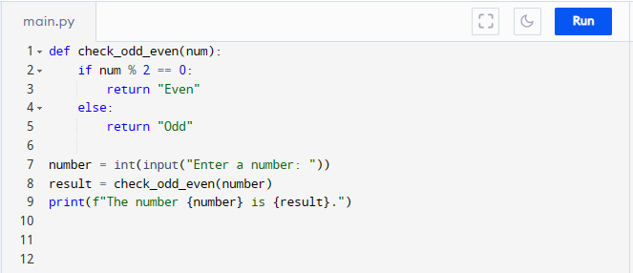

**OUTPUT**

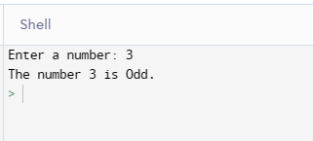

**A Program to determine the age of a user**

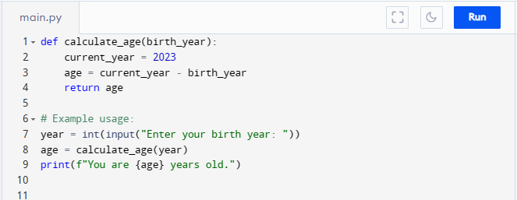

**OUTPUT**

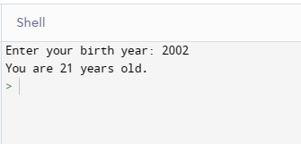

**CHAPTER FOUR**

**4.1**  **CHALENGES**

At the three-month program, l was able to observe some of the problems affecting the smooth operation of activities in the organization *and* these are:

1. Limited number of computer facilities.
2. Limited number of Staff.

**4.2 SUMMARY**

At the completion of the SIWES program, the exercise gave me the opportunity to see myself in real life working condition. It also gave me the opportunity to broaden my thinking abilities, display the things that I have learnt and put most of them into practice. The challenges of modern industrial technological environment.

**4.3 CONCLUSION**

The aim of SIWES is to expose students to practical orientation courses before the end of their program. As for me, it provided me with the opportunity to work in real life organization. Indeed, it was not an easy task but I really appreciate the effort made by the Federal Government and the policy makers in the establishment and initiating the move to setup an SIWES for students.

**4.4 RECOMMENDATION**

In relation to the problems observed during the program, the following solution is highly recommended to enhance smooth operations in Cyber data Automations Ltd.

1. If possible, training and workshop should be provided to both the old and new staff to make them competent of their works.
2. The organization should create a maintenance department so as to take care of their Computers, printers, scanner, photocopying machine, laminating machine and problem that may occur.